RELATIONSHIPS WITHIN FOOD WEBS

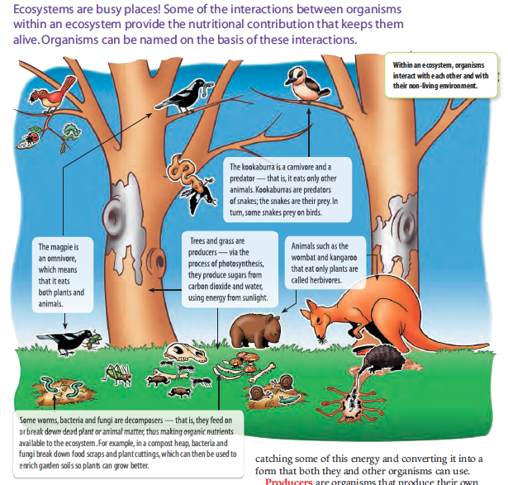

All living organisms require energy to grow and reproduce. This energy is provided by their food source - either manufactured (as in green plants) or as complex foods (found and hunted by animals).

Food chains are used to show the transfer of energy from one organism to another within a community.

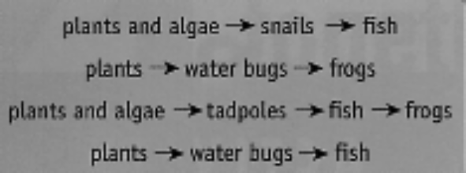
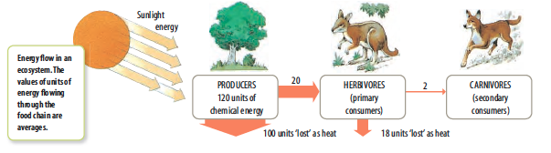
The Sun is the original source of energy for all living things. Energy is passed along from one organism to another. Energy is lost along the way as "heat".

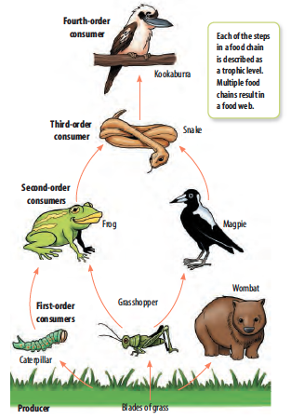
The initial source of food in all communities is the green plants - the producers.

Consumers are those organisms that use (either directly or indirectly) food made by the producers. This includes animals and parasitic plants.

1st order consumers are animals (or plants) that feed on some part of a plant.

e.g. grasshopper, wombat.

2nd order consumers (or higher) feed on other smaller animals.

e.g. frog, magpie.

Food webs show all the feeding relationships in a community. They are composed of multiple food chains.

rabbit
crow
dingo
human
wallaby
sheep
grass
eagle

Decomposers are part of all food chains, but are not usually shown. They breakdown complex organic materials into simple substances to be used by the producers.

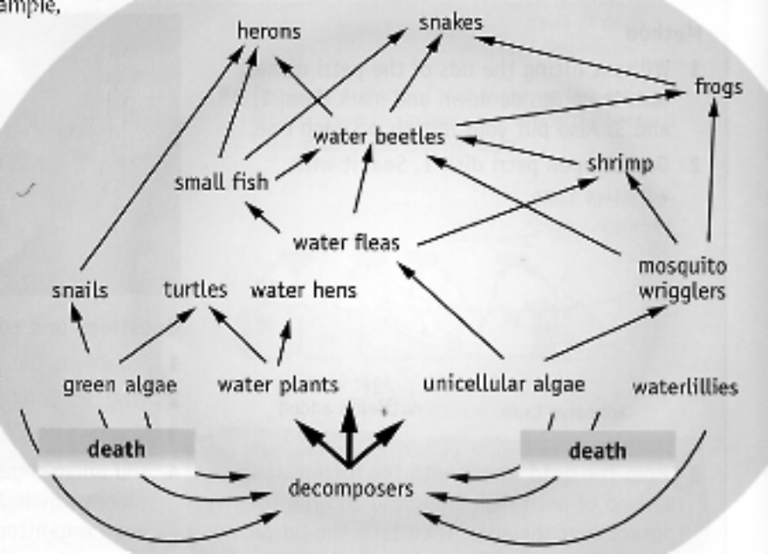

Bacteria and fungi are soil decomposers. They release nitrates and CO₂ that can be used by plants.
